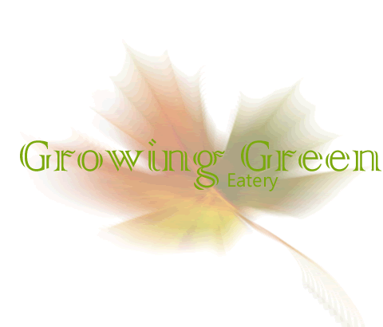

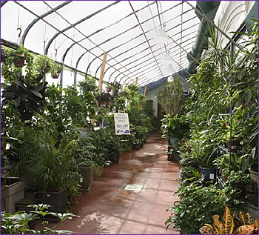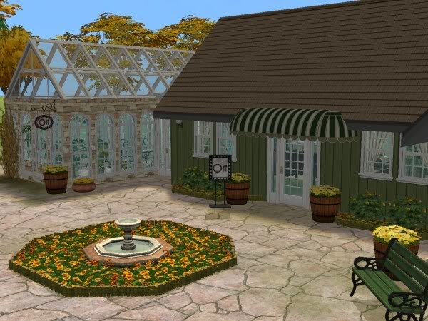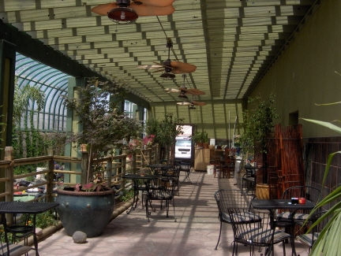

**One Free Entrée**

**Redeemable at Growing Green Eatery Only**

**\*\*One coupon per party\*\***

**Expires 1-1-12**

Visit GoGreenTogether.com for more information or call 348-342-3454 for to reserve a table

**Join us for dinner in the dining room or choose a seat in our greenhouse and dine amongst our dozens of varieties of plants and herbs.**

**Growing Green Eatery is an organic restaurant that grows all its ingredients on site, so our food is always high quality in freshness.**

**Let your first meal be on us!**